Project Abstract

Event: Major Project for MCA 4th Semester

Project name: Wordle Clone

Student name: Suvankar Das (33671021011)

Project guide: Bidyut Das

Technology: HTML, CSS, JavaScript

Project description:

Wordle is a fun and entertaining word-based game for people of all ages. The goal of the game is to form a five-letter word within a certain number of attempts. Usually, players get 6 attempts to guess the correct word. The game is designed to help players improve their vocabulary and spelling skills, as well as to create a fun and challenging experience.

Wordle was created by a Brooklyn-based SWE named [Josh Wardle](https://www.powerlanguage.co.uk/), who wanted to build something *“that focuses on human interaction”*. He created the game for himself and his partner Palak Shah to play, eventually making it public in October 2021. The game gained popularity in December 2021 after Elizabeth S added the ability for players to copy their daily results as emoji squares, which were widely shared on Twitter.

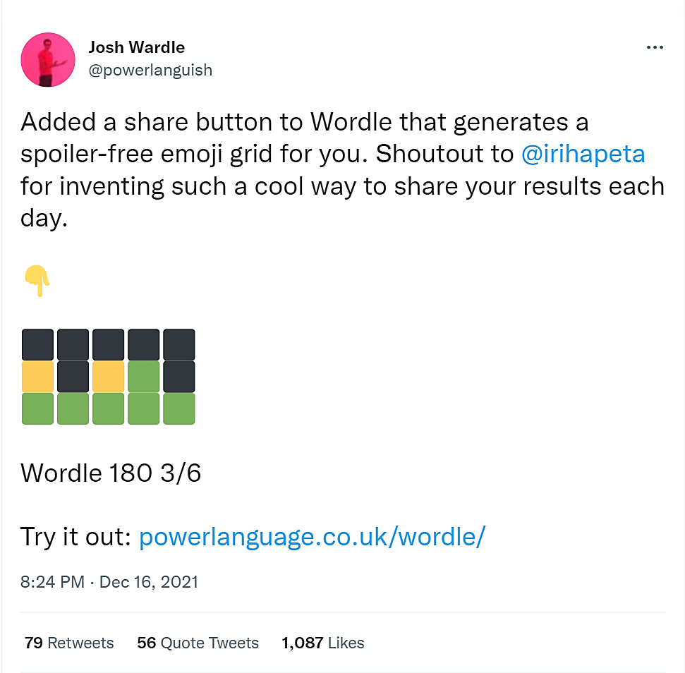

Because of this invention, he was named one of “Time’s Most Influential People of 2022”. The New York Times Company later bought the game from Wardle and has been publishing it since 2022.

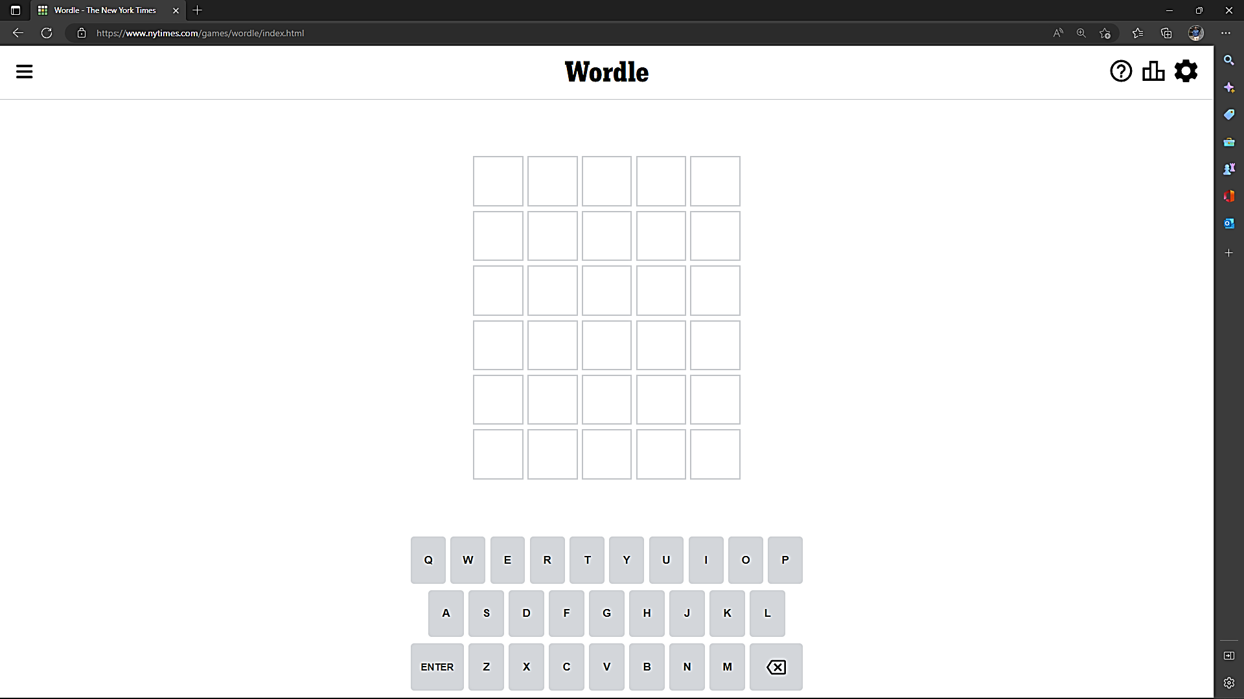

*Fig: Initial user-interface*

It works like this: When you visit the [Wordle website](https://www.nytimes.com/games/wordle/index.html), you're greeted by a 5-wide by a 6-long grid of empty, white boxes. Each box can hold one letter, and you guess the answer by typing in a five-letter word and pressing 'Enter'.

There aren't any clues up front, so any valid five-letter word will do as an initial guess. That's where the game of Wordle really starts. When you press Enter on a guess, the color of each letter of the guessed word changes.

* If it turns green, that letter is present in the wordle, and you've placed it in the right spot.
* If it turns yellow, the letter is in the word but you have it in the wrong position.
* If the box turns grey, it means the letter isn't in the word at all.

The website serves up a simple explainer graphic for first-time visitors that lays it all out clearly.

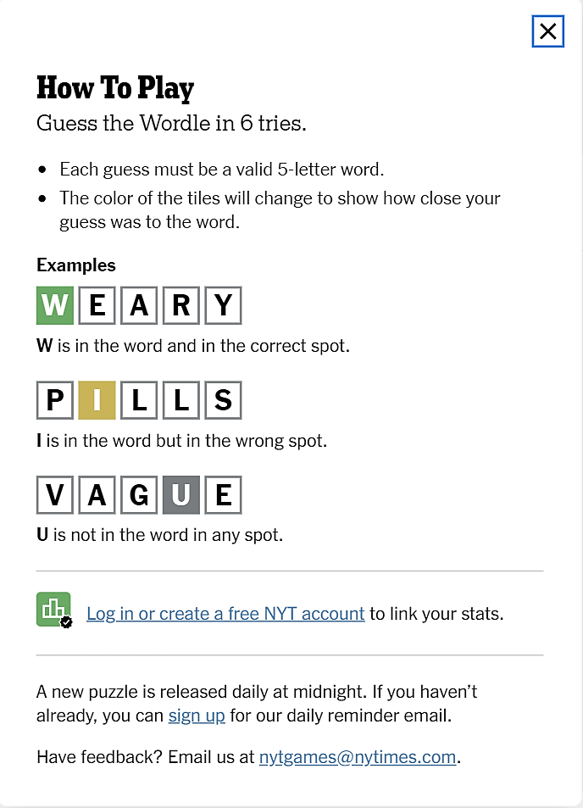

*Fig: User guide*